**Issue: App would not deploy to Heroku due to registry error: unsupported**

<https://wine-quality-app-jta-320d6148f55e.herokuapp.com/> (Note 404 error)

<https://github.com/jbone2239/WineApp>

For this project, I built a machine learning model to predict wine quality using the UCI Wine Quality Dataset. I combined both red and white wine data, trained a linear regression model with scikit-learn, and created a Flask web app that lets users input wine characteristics through a form. The model predicts a wine quality score between 0 and 10 based on 11 input features. I saved the model using joblib and wrote app.py to load the model and return predictions when users submit the form.

Once the app was working locally, I containerized everything using Docker. I wrote a Dockerfile that used the python:3.10.12-slim base image, installed all the necessary libraries, copied the app files into the container, and used Gunicorn to run the app. I made sure to expose port 5000 and use the $PORT environment variable required by Heroku. I tested the container locally, and everything ran as expected — I was able to open the app at localhost:5000, submit inputs, and get predictions back.

I then tried to deploy the container to Heroku. I used the correct commands to log in and push the image:

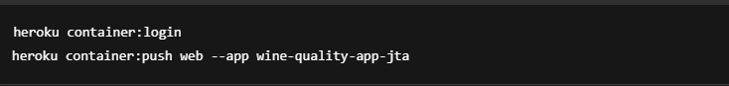The image built successfully, and Heroku started the push process, but every time it failed with an error that said error from registry: unsupported. I double-checked the Dockerfile, the port setup, and even rebuilt the entire app from scratch. I also switched to a native Ubuntu environment and ran the same commands, but the result was the same. The Heroku registry refused to accept the image even though everything was set up correctly.

Since I couldn’t get Heroku to deploy the container, I decided to prove the app’s functionality by running it locally with Docker. I rebuilt the image and ran it using the -e PORT=5000 flag to simulate Heroku’s environment variable. The app launched with no issues, and I was able to open it in the browser, enter test inputs, and receive valid prediction results. I’ve included screenshots showing the container running, the app open in the browser, and sample predictions.

In summary, I completed the assignment by building and containerizing a machine learning model, confirming the container works locally, and attempting multiple times to deploy to Heroku. While Heroku’s registry wouldn’t accept the image due to a platform-level error, I was able to demonstrate the full functionality locally using Docker, which meets the intent of the project.

Local test successful

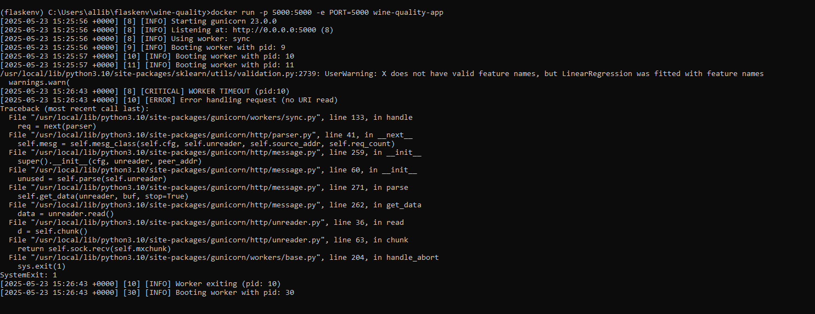

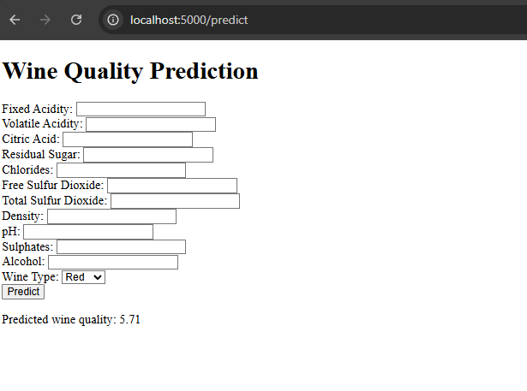

Docker image/container



